|  |  |
| --- | --- |
| Project | nopCommerce |
| Tested By | Ravi Desai |
| Test Execution Date | 28-02-2022 |
| Test Cycle | 1 |
| Version, Build Number | 1,1 |
| Test Scenario Id | TS_ |
| Test Scenario Description | Validate the functionality of the Register function |
| Test Case Id | TC_R_01 |
| Test Case Description | Validate registering an account by providing only the mandatory fields |
| Test Steps | 1. Click on register button  2. Fill all the mandatory fields (First name, Last name, Email, Password, confirm password)  3. Click on register button |
| Test Data | NA |
| Expected Result | Your registration complete page |
| Actual Result | As Expected |
| Test Result | Pass |
| Bug/Defect Id | NA |
| Steps to Reproduce | NA |
| Pre-Requisites | Open the url: https://demo.nopcommerce.com/https://demo.nopcommerce.com/ |

nopCommerce Homepage

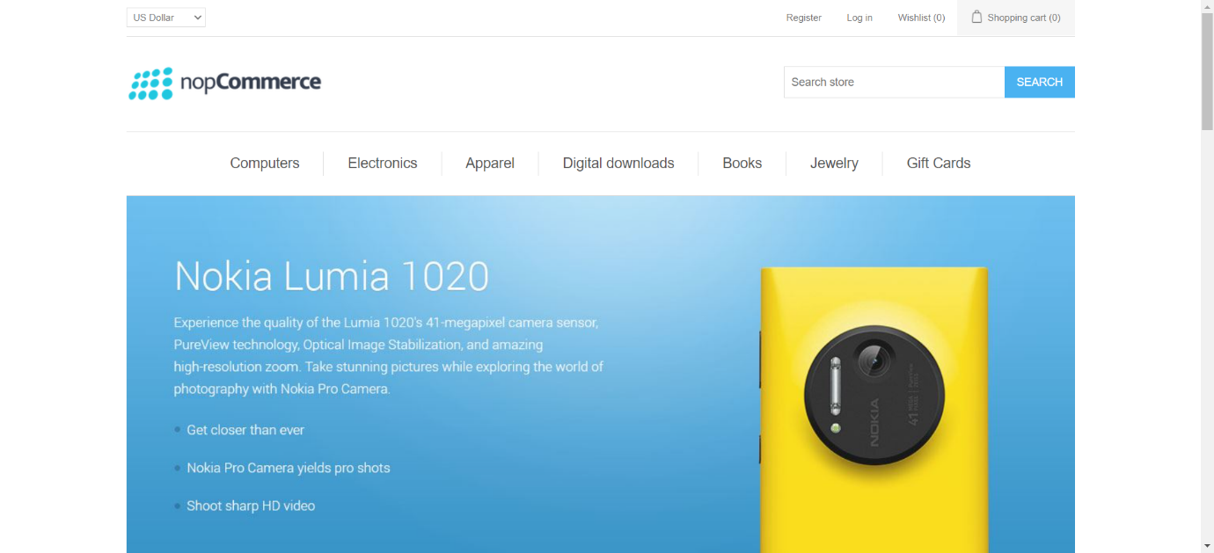

1. Click on register button

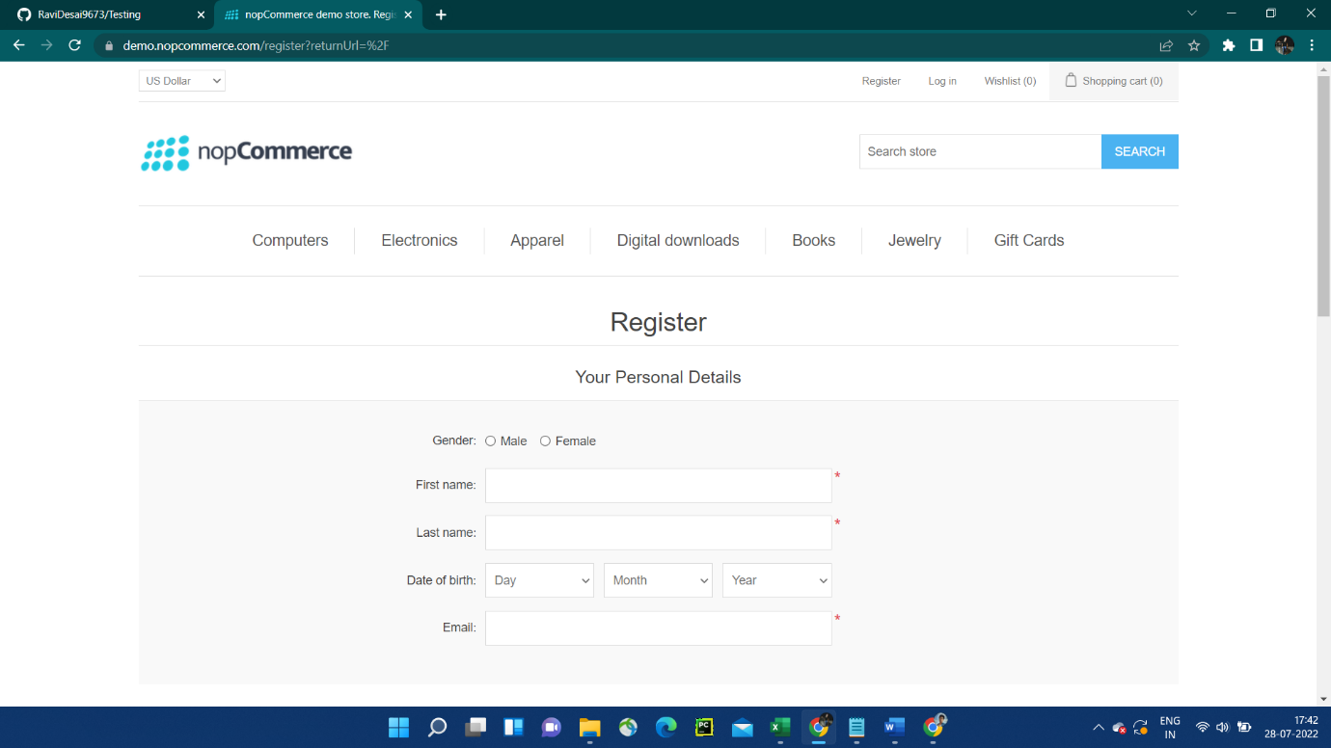

2. Fill all the mandatory fields (First name, Last name, Email, Password, confirm password)

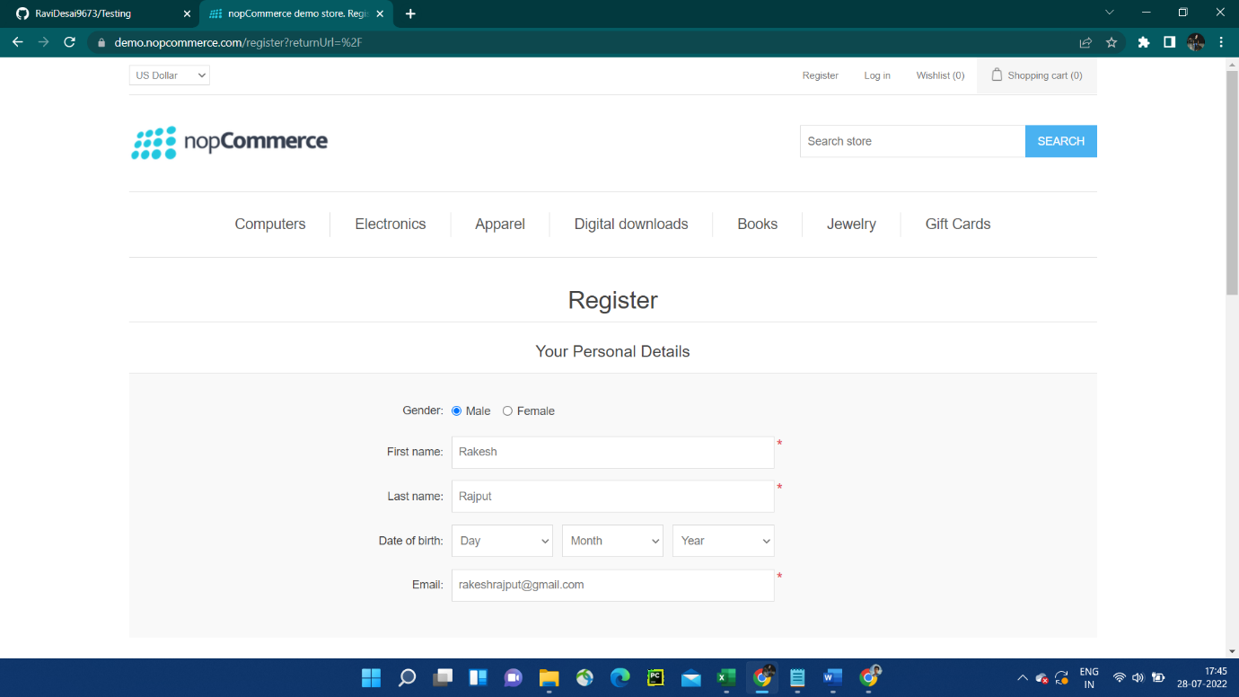

3. Click on register button

